Beach Beats Documentation

Final Game and Controller

The final game that we ended up with for Beach Beats is a beach themed Rhythm game to the song Crab Rave by Noisestorm. For the controllers we created Turtle Bongos from wood, styrofoam, two turtle plushies, two arcade buttons, and a teensy. The bongos control the left and right arrow keys which are used to hit the left and right arrows as they drop down from the top of the screen in Beach Beats.

Timeline

Aug 30th: Team Formation and brainstorming

Sept 6th: No Class, continued brainstorming and ordering parts

Sept 13th: Unity Work Start

Sept: 20th: Hardware and Turtle work Start

Sept 27th: Soldering and Wiring Begins/Turtles and Fabrication of Controllers Done

Oct 4th: Work Day/Soldering to Teensy Done/Teensy Case done.

Oct 11th: Game Done/Presentation

Unity/Game Creation (Sept 13th):

The assembly of the Unity game was a thorough and hard process to construct. Most of the help was made possible through the Youtuber Gamesplusjames and his rhythm game tutorial videos  
  
<https://www.youtube.com/playlist?list=PLLPYMaP0tgFKZj5VG82316B63eet0Pvsv>  
  
I provided the turtle assets and crab rave video in the background as my own contribution. After that we had to individually set up each arrow to align with the music of the game and arrange the code to align with certain points of the button to provide the Hit, Miss, Good, Perfect pop up words in the game.

Fabrication (Sept 20th):

The fabrication of our controllers is a system of styrofoam with a button suspended in the middle. This is enclosed within a turtle plushies shell. This whole system sits on top of a wooden base board with holes drilled in for wire access

Early Mockup

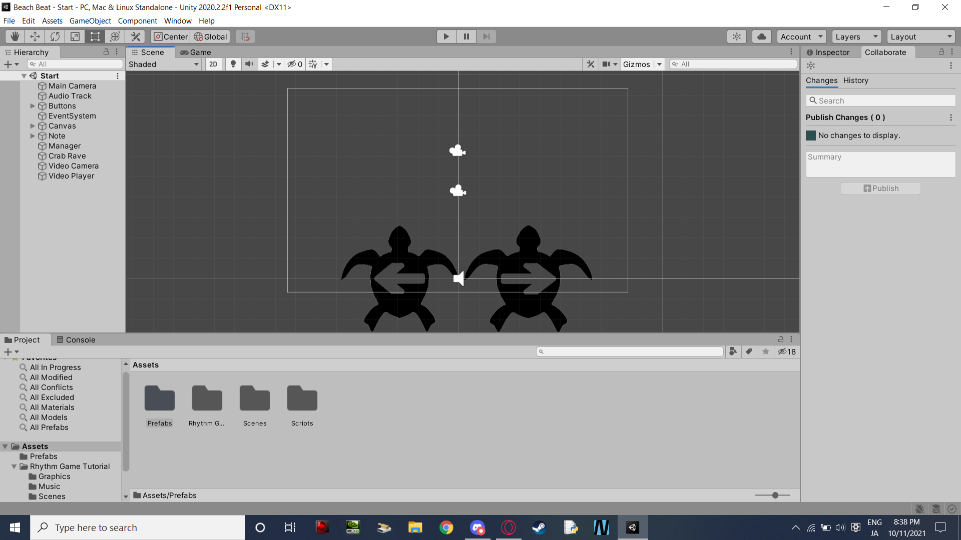

Screenshot of the game before the arrows were added to the screen

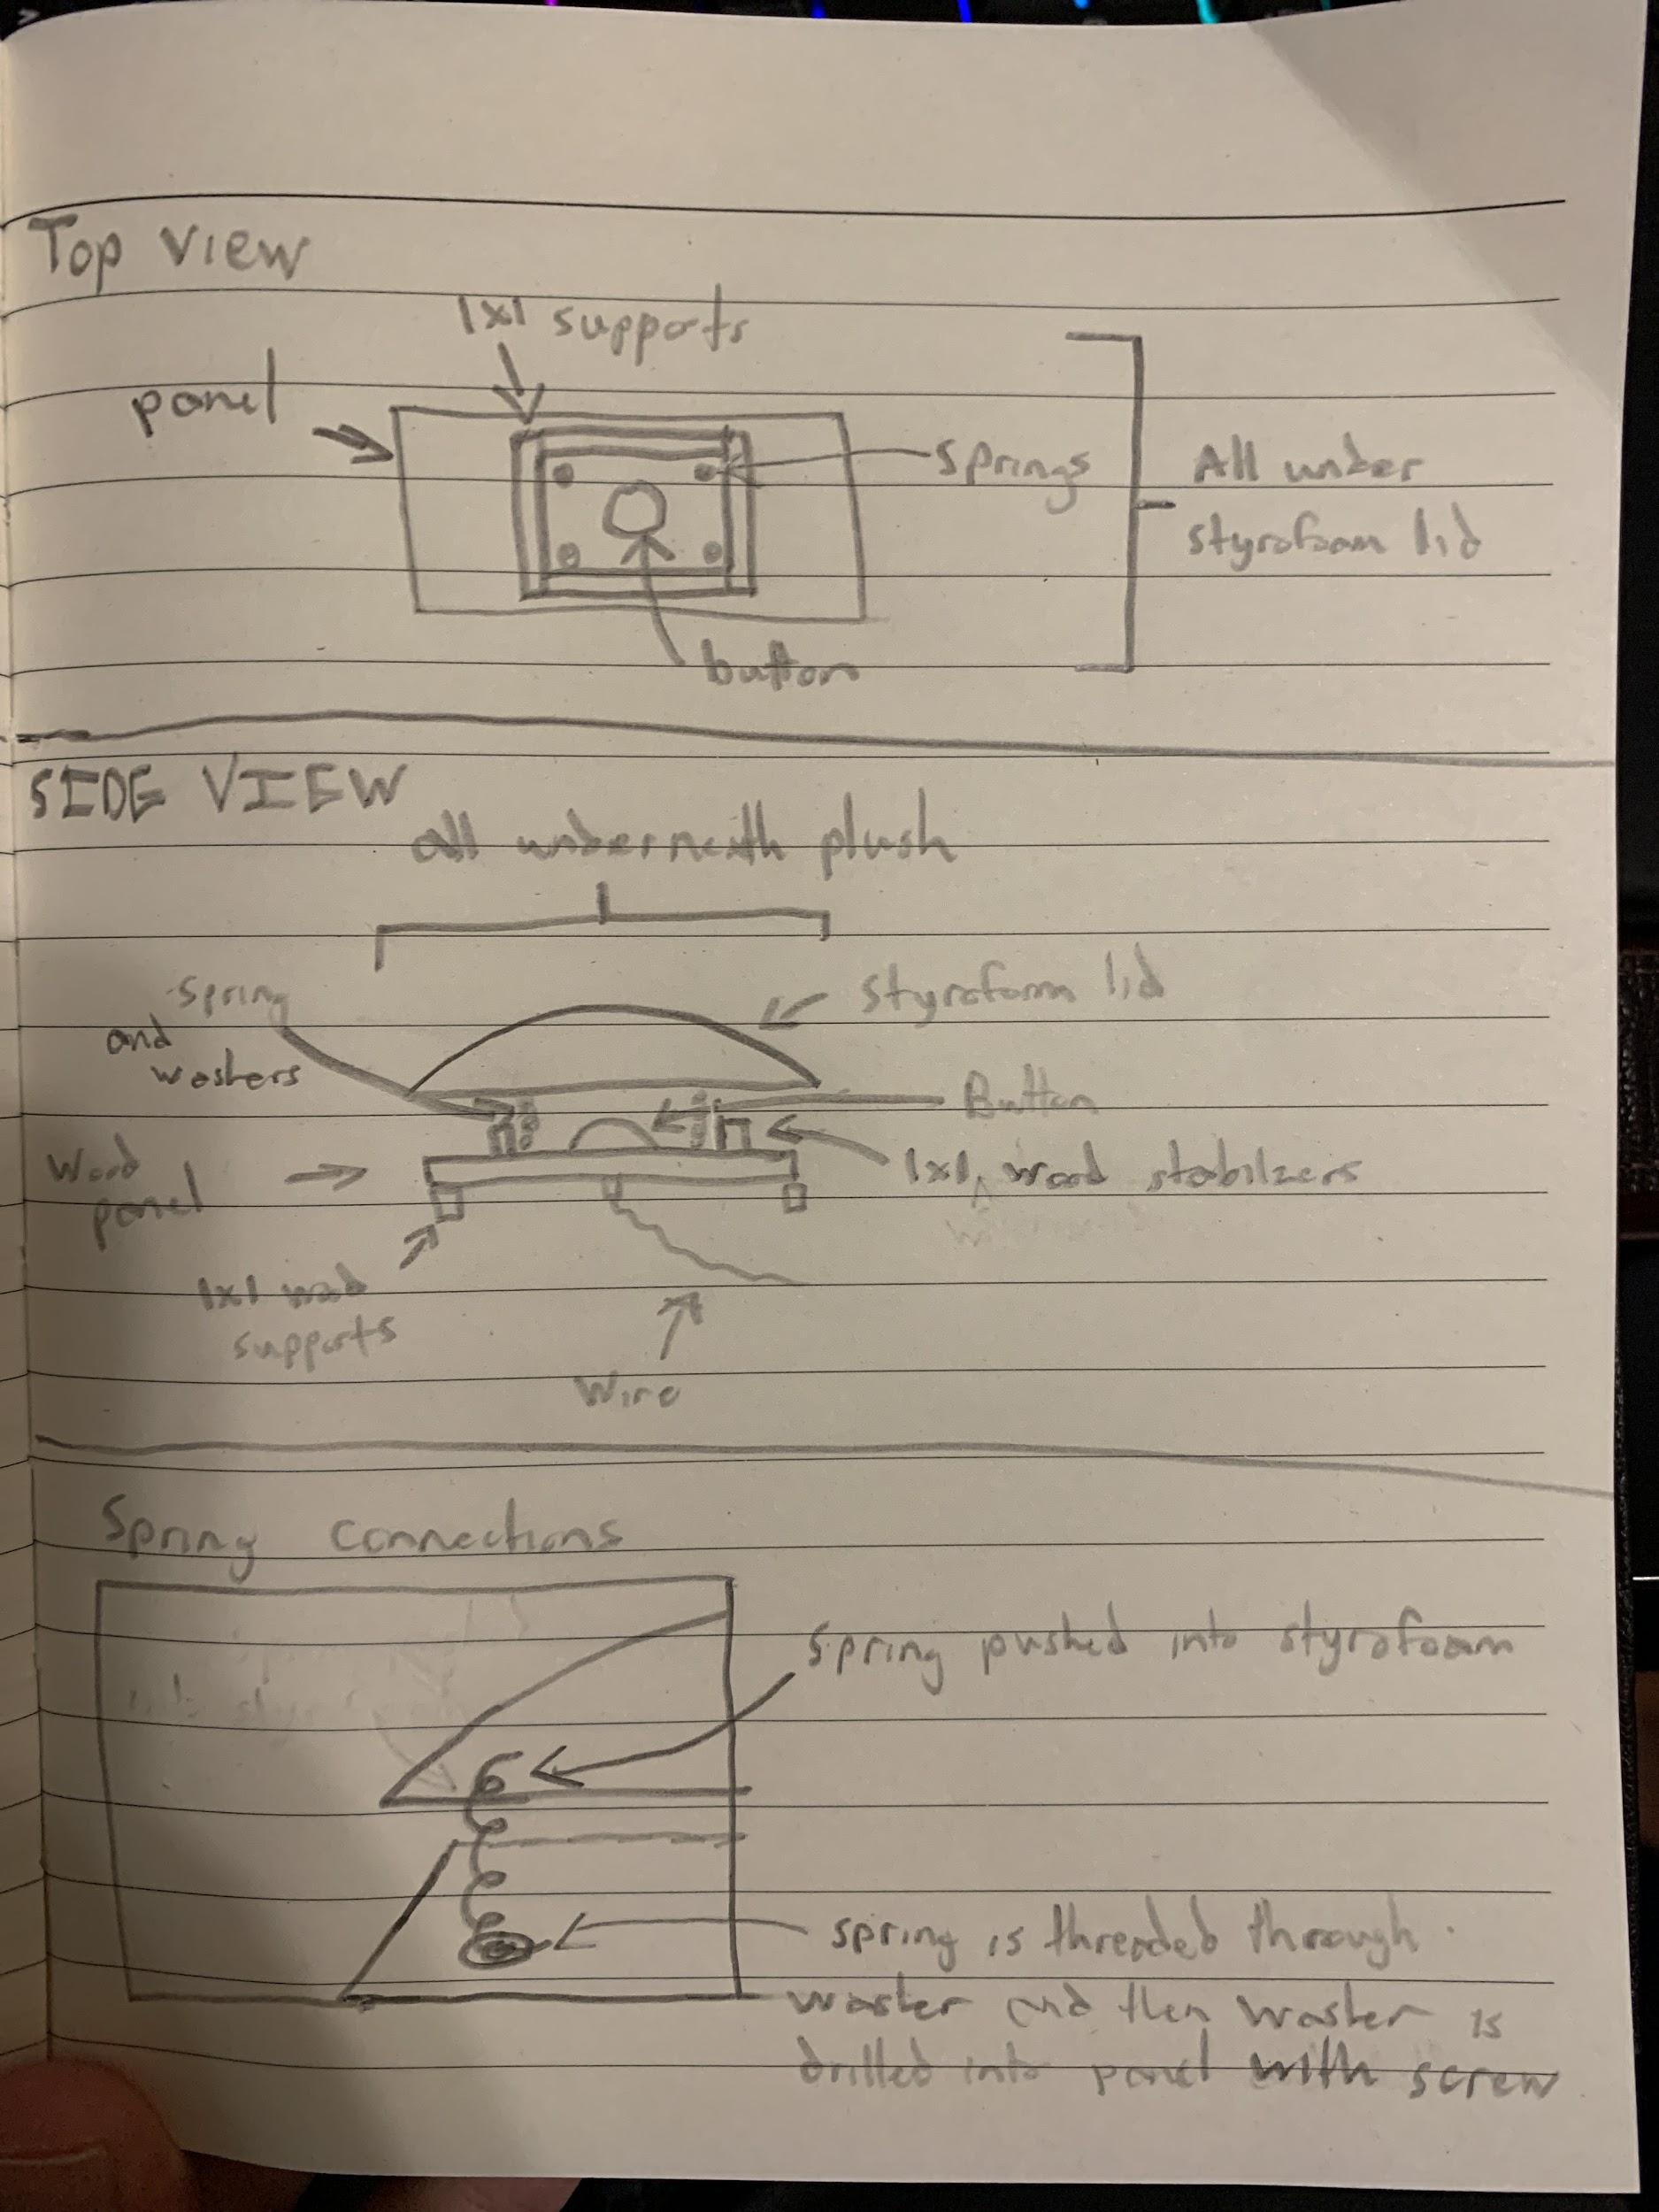

Final design front and undercarage

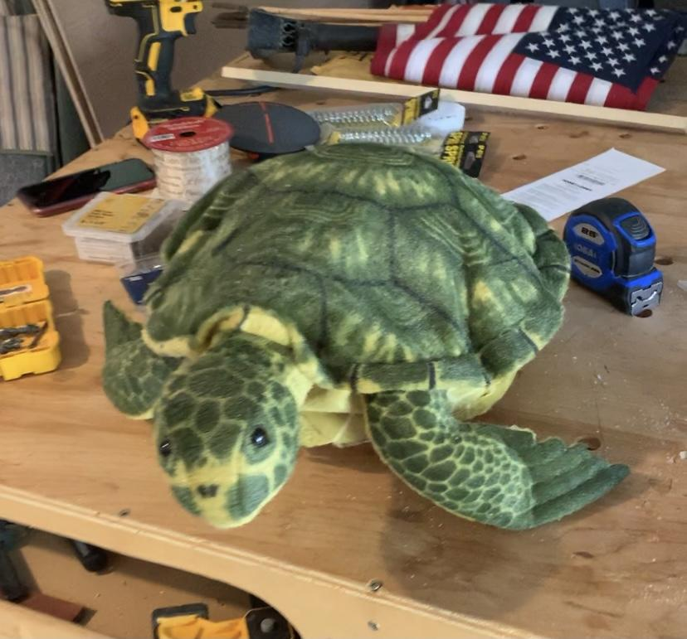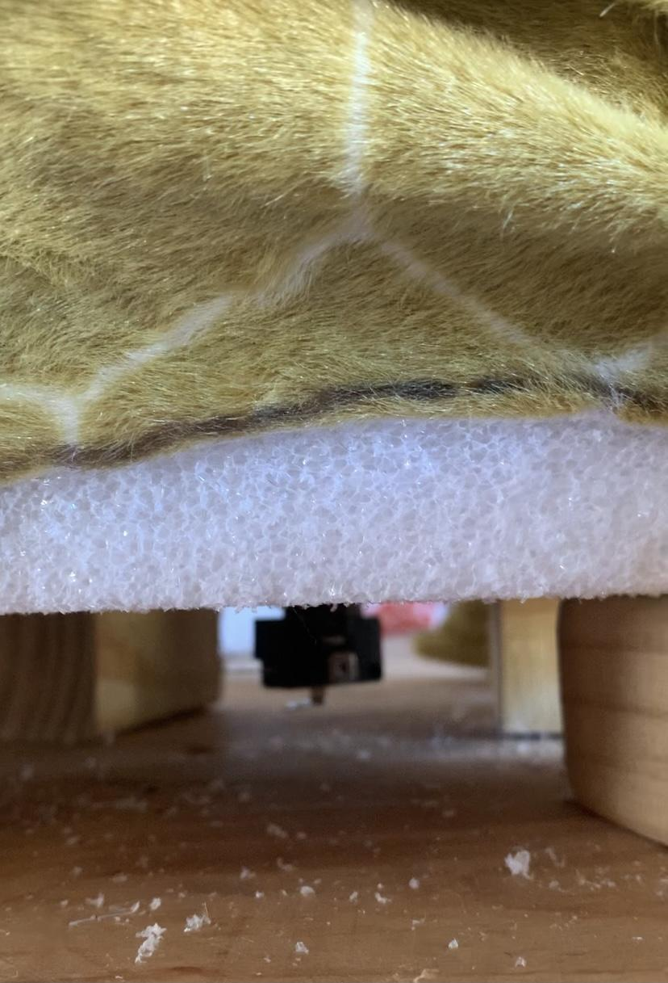

Wiring/Soldering/Teensy Coding (Sept 27th/Oct 4th):

The wiring was first tested using an Arduino Uno and a breadboard. The wiring scheme was followed almost exactly when figuring out the way the project was going to be wired. When wiring the buttons to the Teensy, there were two different spots on the parts of the button, one of which we used for ground and signal, the other we used for the positive. When wiring, I used the inputs from slots 19 and 7 for the two buttons. There was an issue with slot 17 giving a constant signal which I had to cut the wire from and replace with slot 7. The wiring was the three cables, ground, power, input, going to their respective ports and to the button. There is a resistor soldered onto the grounds of each button. The following will be showing the code while testing using the Arduino, the code for the Teensy, and pictures showing the wiring and soldering.

Arduino Code:

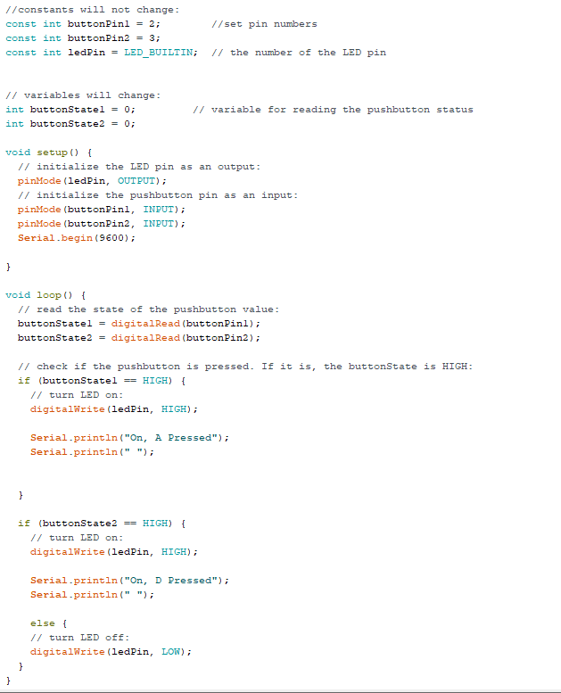

Teensy Code:

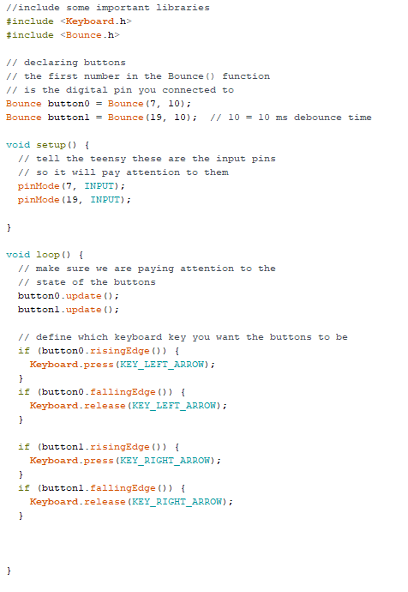

Wiring for Arduino Uno:

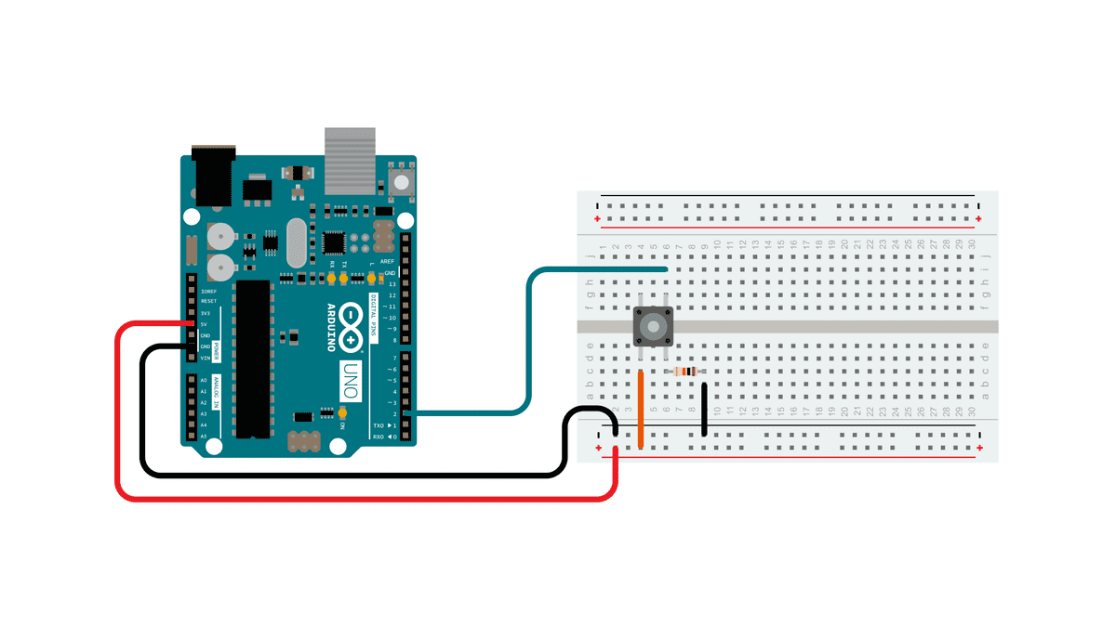

Wiring on Button:

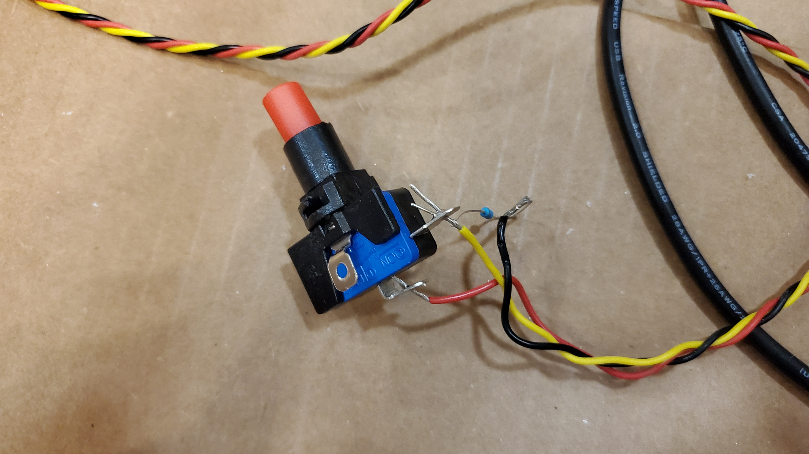

Button on the Bottom of Controller: 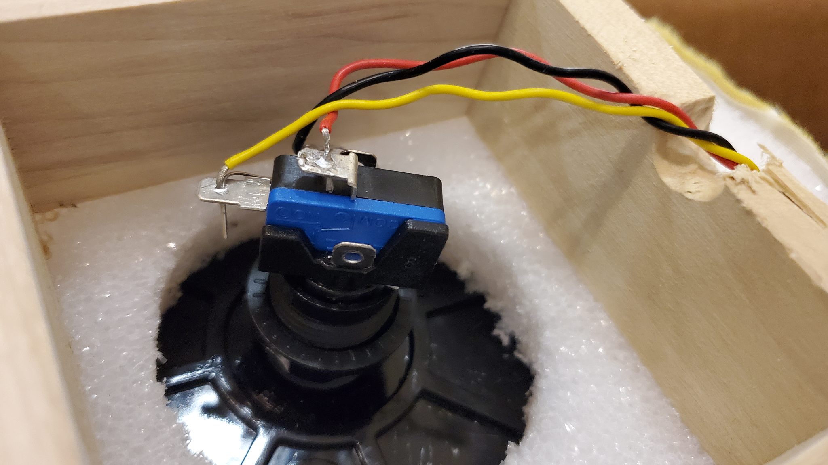

Bottom of Teensy: 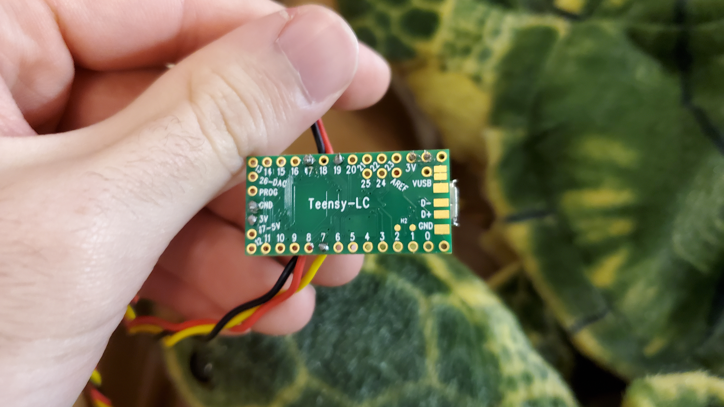

Top of Teensy:

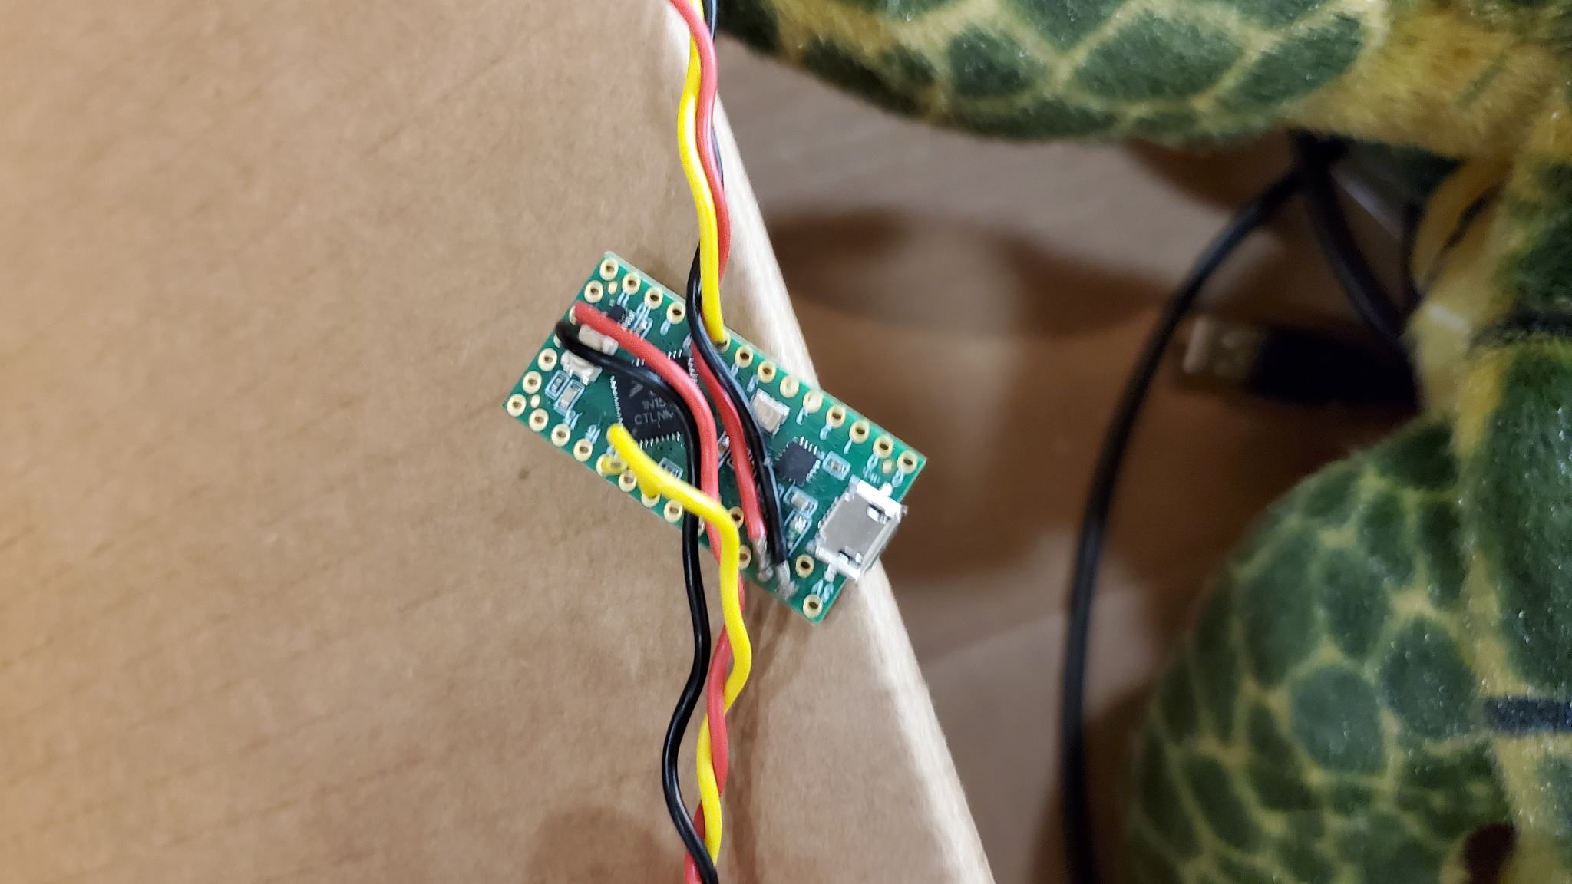

Teensy Case: 